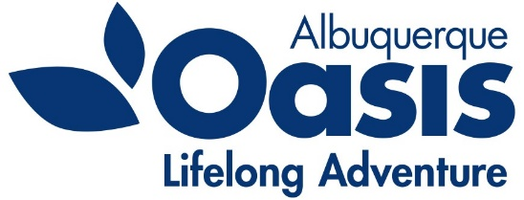
Oasis – Albuquerque
PO Box 35518
Albuquerque, NM 87176
505.884.4529
505.884.4942 Fax
www.oasisabq.org

____________________________________________________________________________________________________________

Oasis Albuquerque
Board of Director’s Meeting
Agenda
Thursday, April 6, 2023
9:00 am (MT)

- Call to Order – Lorna Wiggins
- Consent Agenda items:
  - Approval of the December 2022, January 13, 2023, and February 28, 2023 minutes
  - Financial Report: February 2023 financials
- Chair’s Report - Lorna
- Executive Director Report – Kathleen
- New Business –
8. Old Business
New board member (continuing) discussion
Area Agency on Aging Funding report
9. Adjourn

Executive Session – if needed

Next meeting: TBD

