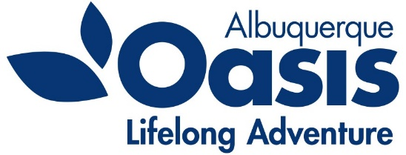
Oasis – Albuquerque
PO Box 35518
Albuquerque, NM 87176
505.884.4529
505.884.4942 Fax
www.oasisabq.org

____________________________________________________________________________________________________________

Oasis Albuquerque
Board of Director’s Meeting
Agenda
Thursday, September 8, 2022
9:00 am (MT)

- Call to Order – Lorna Wiggins
- Consent Agenda items:
  - Approval of the June 2022 minutes
  - Financial Report: July 2022 financials
- Chair’s Report - Lorna
- Executive Director Report – Kathleen
- New Business
8. Old Business
Area Agency on Aging Funding report
9. Adjourn

Executive Session – if needed

Upcoming Events:
Taste of Oasis – Friday September 16, 2022 @ Oasis

