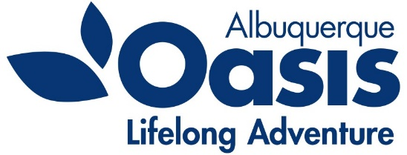
Oasis – Albuquerque
PO Box 35518
Albuquerque, NM 87176
505.884.4529
505.884.4942 Fax
www.oasisabq.org

____________________________________________________________________________________________________________

Oasis Albuquerque
Board of Director’s Meeting
Agenda
Thursday, March 3, 2021
9:00 am (MT)

- Call to Order – Lorna Wiggins
- Welcome new board members – Chrissy Akes and William Itoh
- Consent Agenda items:
  - Approval of the December 2021 minutes
  - Financial Report: December financials
- Chair’s Report - Lorna
- Executive Director Report – Kathleen
- **Rubin Brown, CPA – Liz Arro
- New Business
Area Agency on Aging Funding report
Marylen Mann 85th birthday celebration
- Old Business
- Adjourn

**New auditing standards in effect for the 2021 audit year require more formalized auditor communications with organizations’ boards prior to the beginning of audit fieldwork.

