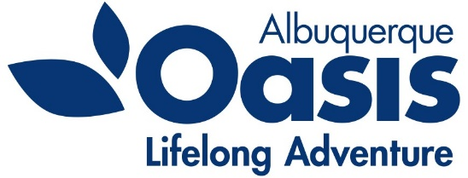
Oasis – Albuquerque
PO Box 35518
Albuquerque, NM 87176
505.884.4529
505.884.4942 Fax
www.oasisabq.org

____________________________________________________________________________________________________________

Oasis Albuquerque
Board of Director’s Meeting
Agenda
Thursday, December 2, 2021
9:00 am (MT)

- Call to Order – Lorna Wiggins
- Consent Agenda items:
  - Approval of the September 2021 minutes
  - Financial Report: October financials
- Chair’s Report - Lorna
- Executive Director Report – Kathleen
- New Business
Area Agency on Aging Funding report
2022 Budget discussion
- Old Business
Investment account wrap-up
New board member brainstorm
- 2022 Meeting schedule
- Adjourn

