Category: Cultural Heritage
Genre: Historical Fiction
Oasis Tutor: Judy
Student/Grade: Betzy - grade 4

Summary: Judy’s story is not an uncommon one in APS and, undoubtedly, other schools around the state. Children who come from Spanish speaking homes enter school with a language disadvantage. In most schools, instruction and materials are in English. Children, like Judy’s student, are immersed in English speaking schools, but return to a home where Spanish prevails. Judy selected a book that gave voice to her student’s heritage in a way that was far more meaningful than Judy ever imagined.

The Story:
Betzy, Judy’s student whom she tutored for two years, came from a close knit family. She lived with her parents, grandparents, and two siblings. The family came from Zacatecas, Mexico and, naturally, the language spoken at home was Spanish. Betzy’s parents understood the importance of education. Betzy’s mother came to school one time, specifically to meet Judy. The importance of church and appropriate behaviors were also home teachings that Betzy demonstrated at school.

Betzy, her younger brother, and her older sister were rewarded for academic achievement. A trip to Six Flags was one such prize. There are still relatives living in Mexico and summers are spent there, where Spanish is probably the only language spoken.

The classroom teacher, when Betzy was in fourth grade, recognized that Betzy was bright and had a lot of potential, even though she struggled with English. The teacher thought she would benefit from time with an Oasis tutor. Judy says that Betzy had plenty of English language reading deficits when she first met her—vocabulary, grammar, and punctuation, along with pronunciation problems. Judy saw that the child was not comfortable with English and needed to gain self-confidence to excel.

Judy was familiar with the American Girl book collection, by Valeria Tripp. which spotlights girls from many different heritages. Each girl has several books about them, their family, their cultural traditions, and their fictional-based-on-fact lives. Judy decided to share one of the books with Betzy about Josephina, a girl living in 19th century New Mexico (before it was a state). The book is all about Epiphany, also known as the Day of Holy Kings (Día de los Santos Reyes). The holiday is celebrated on January 6 in remembrance of the biblical story of the three kings' visit to Jesus. Coincidentally, Judy brought the book to read with Betzy right after Christmas. The date was January 6! It seemed to bring about a deeper connection between Judy and her student as Betzy shared her family traditions.

Judy reports how she and Betzy had beautiful conversations relating to what Josephina experienced and compared those with what Betzy experienced. The book’s content spoke to Betzy’s life. At the same time, it gave Betzy an unexpected glimpse of what things were like in the time frame 200 years earlier. There are nine books in the Josephina series and Judy and Betzy read several of them. The stories take place in Santa Fe and portray how the families lived and earned a living, how they dressed, the family structure, and customs of the time. Contrasting Josephina’s life to Betzy’s was, in Judy’s estimation, an amazing experience
for them both.

Judy indicated that Betzy blossomed and by 5th grade probably didn’t need to meet for reading improvement. Judy, however, was delighted to have her for another year and witness Betzy’s newfound confidence and blossoming friendships with her classmates.
.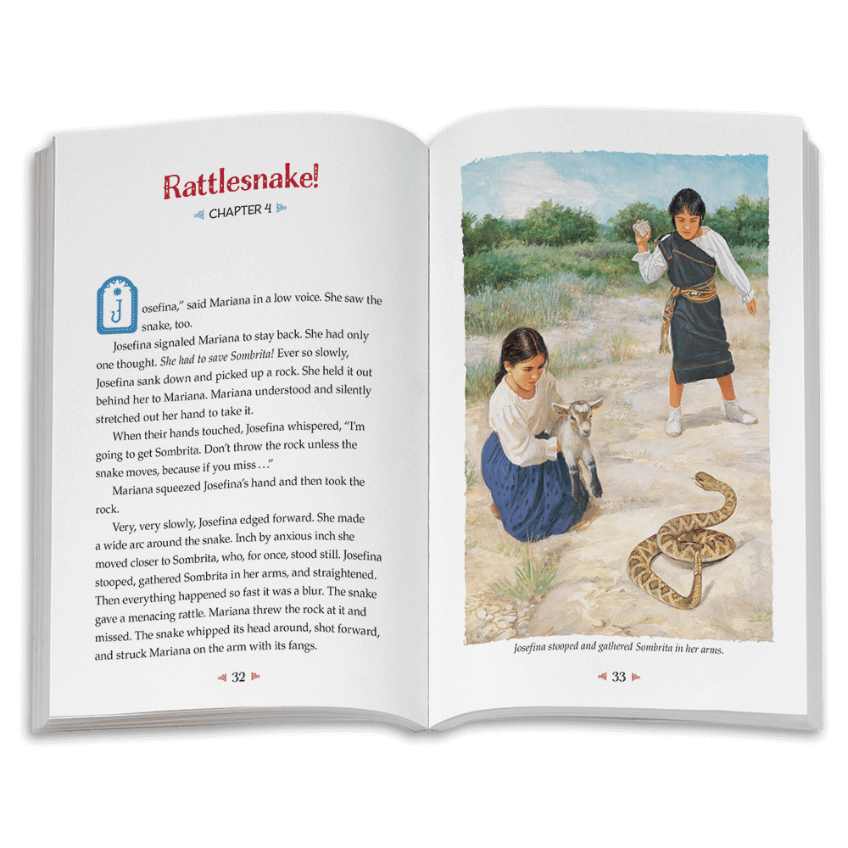

Judy’s Discoveries:
- Judy often used her own intuition to connect with the children she tutors
- This particular series of books felt especially meaningful because of her student’s ability to relate to the character in the book
- Reading this series was an exceptional way for Judy to connect with her student. She looks for other opportunities such as this one to make a connection to the student.
- Judy spends detailed time with the “About Me” booklet in the beginning of each year. In this way, she can really get a feel of the students’ likes, needs and where to start to develop a close relationship

About Judy:
Judy has been an Oasis tutor for six years. She spent a career in real estate but switched gears to work for an Albuquerque synagogue as an administrator after moving here. Judy volunteers at an Albuquerque elementary school, teaches the Matter of Balance Class at Oasis, loves walking in the Bosque and is very happy to be in New Mexico for the past 24 years.

Other Recommended Books:

There are at least a dozen “American Girls” in this series, along with other “spin off” books. They are available from the Albuquerque library and most likely in school libraries. They are on Amazon in a variety of formats and, probably available from some used book sites.

There is a much smaller series for boys put out by author Valerie Tripp called Boys Camp. It is not as extensive as the American Girl series, but may be worth a look.

